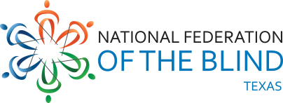

NFB of TEXAS CAREER Mentoring Program: Monthly Newsletter

horizontal line

# Steer Towards your CAREER

Mentoring teams welcome to our first CAREER program e-newsletter! We'll keep this publication short, so you can get back to what matters most- killing it at school/work, TikTok, and connecting with the blind community.

Clock It and Rock It

Tips to build your mentoring partnership

Catching up with each other for at least 4 hours a month is one of the best ways for the mentoring vibe to stay strong. Finding a shared interest or experience to discuss is key to building a real connection with each other. This month, do your best to find common ground amongst yourselves. If you need them, here are some fun questions to jumpstart the conversation:

1. What TV or movie character is most like you and why?
2. What is an activity you did as a child that you wish you could do more of now?
3. What is your dream job?
4. If you could learn to play any instrument, what would it be?

horizontal line

Opportunities in our Community

## Newsline Internship Opportunity

Our Newsline program is seeking part-time support talking with subscribers regarding their experiences accessing content. The work schedule is flexible and requires a friendly, organized, and professional individual to collect subscribers' information. For more information, contact Norma Crosby at Ncrosby@nfbtx.org or (281) 824-4045.

horizontal line

# CAREER Community Close Up

Introducing Demetria Ober!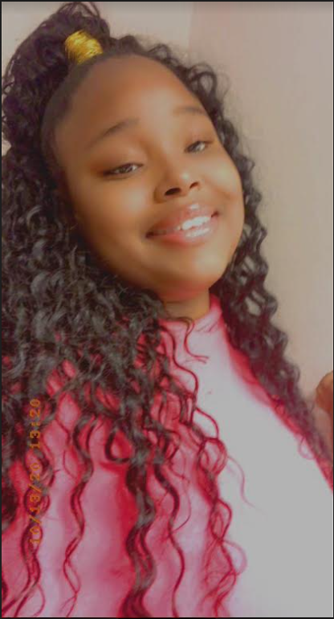

My name is Demetria Ober and I am a Junior attending Texas Woman’s University. I am studying Social Work, and minoring in Medical Spanish Interpretation. My ultimate goal is to be accepted in the Social Work Graduate school program. My hobbies currently include, reading, researching, practicing self-care—both mentally and physically, writing, and playing with my adorable service dog Flash, as well as my other puppies, Socks and Lady.

Being involved in the NFBTX mentoring program has taught me many lessons. I am more confident in my abilities as an up and coming successful individual that experiences blindness. Before I joined NFB, I was extremely afraid to put myself in new situations due to the fear of failing, but now I enjoy taking risks. I have developed the motto, ‘I am not lost, I am exploring.’

My NFB family has encouraged me to push myself to participate in the upcoming Fall 2021- Spring 2022 academic year abroad—in Granada, Spain—where I will be studying in the intensive Spanish language program. I feel honored to be involved in a group as supportive and encouraging of independence. I have made connections, networked, and learned from admirable successful blind/visually impaired individuals.

I have also had the opportunity to be mentored by a great woman and leader, in which I am truly inspired by. My mentor Liz, has been a great resource for me. She definitely makes sure I am striving to be the best possible version of myself, by offering valuable knowledge, and bringing different opportunities to my attention.

I have also applied and began working as a caretaker, which is something that I always wanted to do, but in the past feared rejection. In total, I have grown into a confident, risk taking, determined young leader who is now unapologetic about being who I am. I have learned that my blindness is not who I am, but a part of my daily experience. I owe my new found view of life thanks to NFB and the mentoring program.

# Happy Birthday Friends

Put on your party hats to wish these members of our mentoring community some birthday love!

Evelyn Luna and Jonathan Stewart ,May 3  
Syed Rizvi, May 14

horizontal line

# Upcoming Events

Find out what’s coming up next!

May 1 from 1-4 Student Summit

May 23 at 2:30 PM College and Career Virtual Session



NFB of Texas

1600 E Hwy 6 Ste 215, Alvin TX 77511